PatientID FirstName LastName PatientHeight PatientWeight



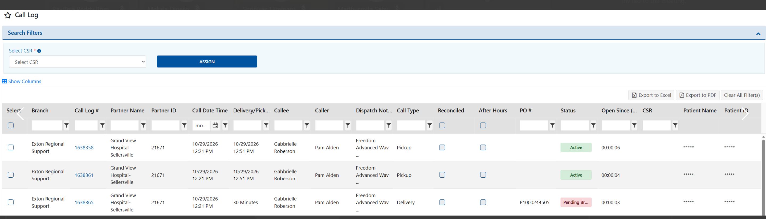

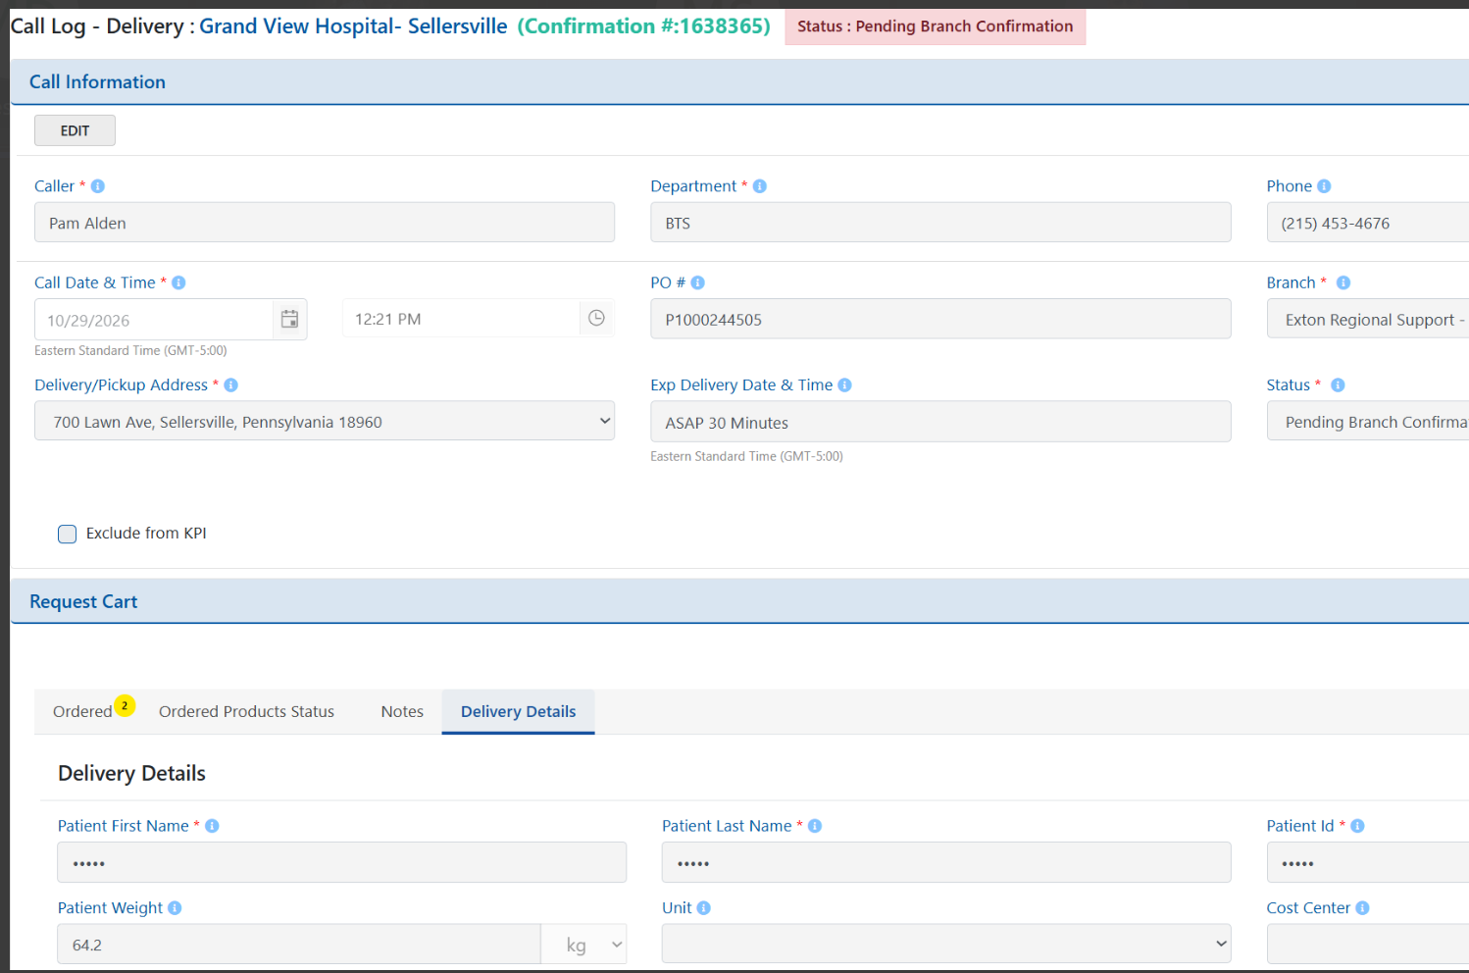

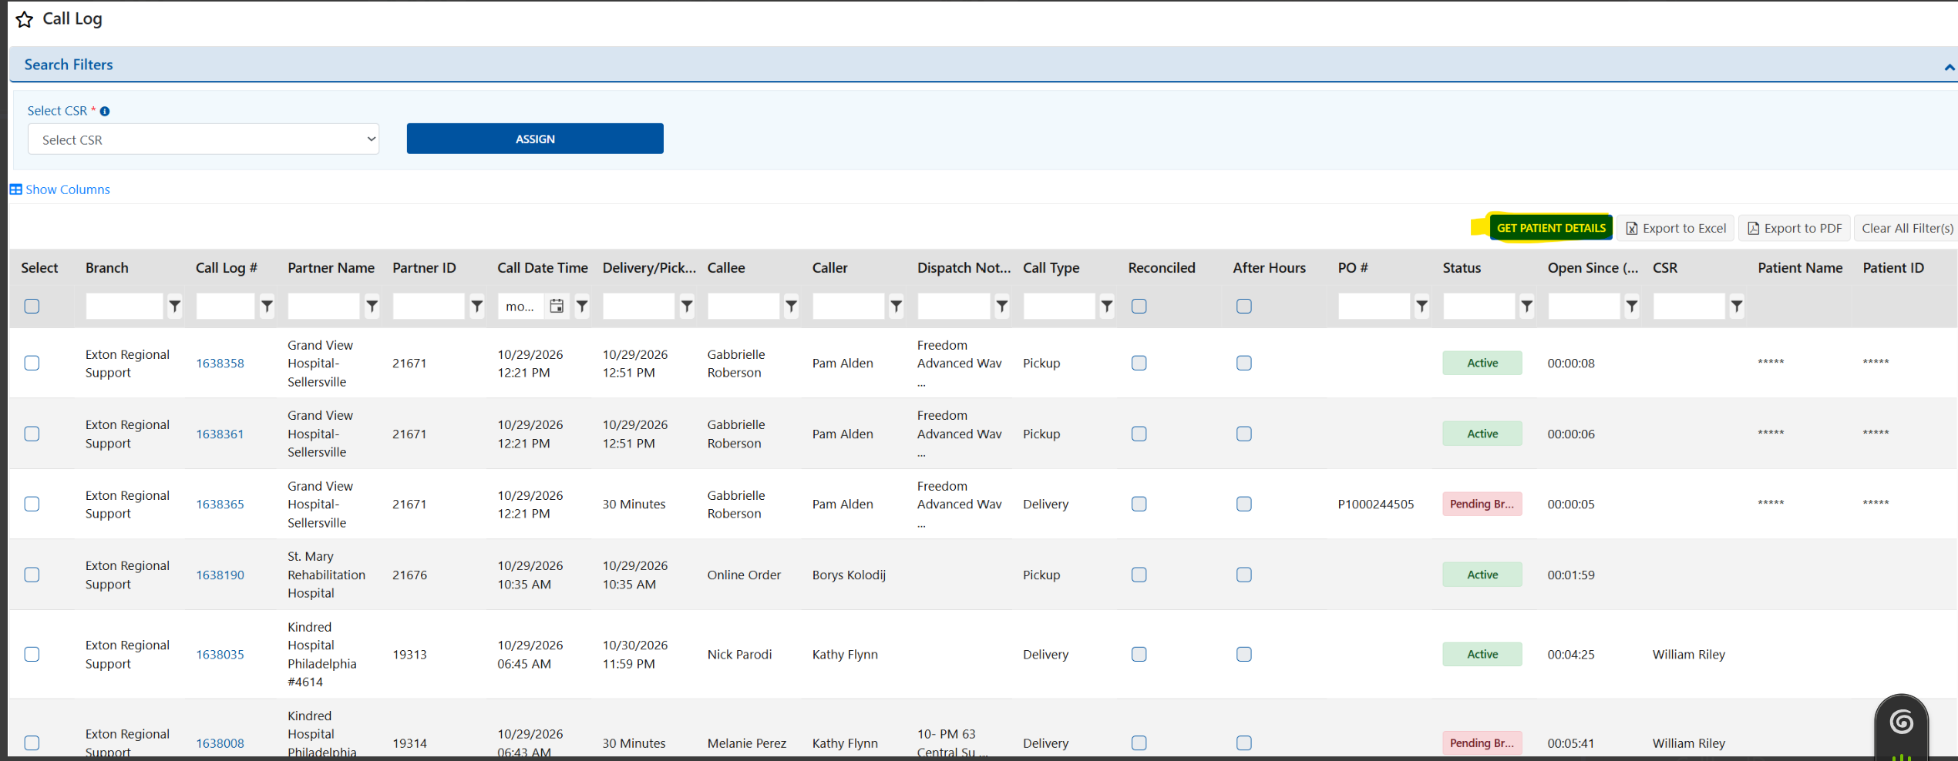

CallLogPatient:

CallLogPatientDetailID CallLogID PartnerUnitID PatientID FirstName LastName PatientHeight PatientWeight DeliveryLocation CreatedBy CreatedOn ModifiedBy ModifiedOn IsActive PFPartnerUnitID PFCalllogID PFID

entalOrderPatientDetails:

RentOrderPatientDetailID ROItemID PartnerUnitID PartnerContactID PatientID FirstName LastName DeliveryLocation IsCurrentDetail Comments IsActive CreatedBy CreatedOn ModifiedBy ModifiedOn PFPartnerUnitID PFROItemID

Common.PHIAccessAuditLog:

PHIAccessAuditLogID PatientID PatientFirstName PatientLastName AccessedFromScreenName APPSourceID EntityID EntityType UserID UserName IPAddress CreatedBy CreatedOn PatientDetailID SubMenuID ModifiedBy ModifiedOn

